6.3.1 Search activity - Searching for pharmaceutical patents: You might have heard of some drug by the name Arnuity Ellipta®. Let us look at the patent coverage for this drug.

Arnuity Ellipta® is a well-known prescription inhaled corticosteroid medicine taken as 1 inhalation, once daily, for the control and prevention of asthma in adults and children aged 12 years and older. ARNUITY helps to prevent and control symptoms of asthma. ARNUITY is not for use to treat sudden symptoms of an asthma attack, wheezing, cough, shortness of breath, and chest pain or tightness. ARNUITY won't replace a rescue inhaler. It is currently marketed by GlaxoSmithKline.

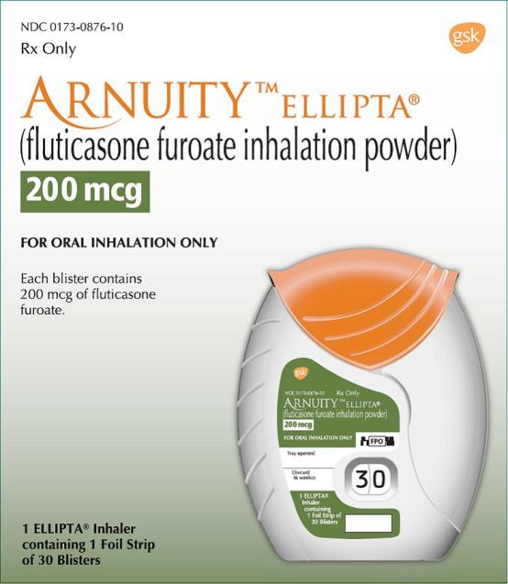

Let’s try to find out the patent which covers the Arnuity Ellipta®.

Where do we start?

Step | Description of step: | Model answer:
1 | Think of what clues you have. | You know the brand name Arnuity Ellipta®.  You need more information.
2 | Think of what resources you have available to you and how you can use them to find the answer. | Go to Google and type in Arnuity Ellipta. You will see that Arnuity Elliptais a GlaxoSmithKline product and has the active ingredient Fluticasone Furoate .  Alternatively you can go to the FDA orange book site http://www.accessdata.fda.gov/scripts/cder/ob/default.cfm and click “Search by Proprietary name”. Type Arnuity Ellipta in the search box and hit enter.  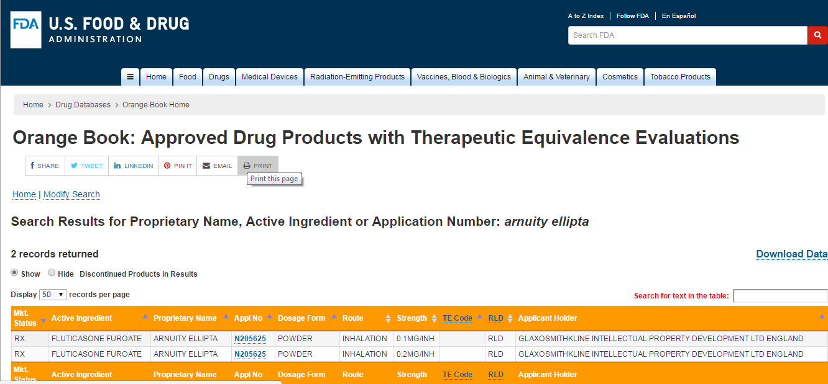
3 | What information have you found out? | The search results display the Active ingredient in Arnuity Ellipta, the applicant and the Application Number.  Click on Application number N205625 to find out more information.
4 | How can you look for patent information related to the product? | Product Details for NDA 205625  Expand all  ARNUITY ELLIPTA (FLUTICASONE FUROATE)  0.1MG/INHMarketing Status: Prescription  Active Ingredient: FLUTICASONE FUROATE  Proprietary Name: ARNUITY ELLIPTA  Dosage Form; Route of Administration: POWDER; INHALATION  Strength: 0.1MG/INH  Reference Listed Drug: Yes  TE Code:  Application Number: N205625  Product Number: 001  Approval Date: Aug 20, 2014  Applicant Holder Full Name: GLAXOSMITHKLINE INTELLECTUAL PROPERTY DEVELOPMENT LTD ENGLAND  Marketing Status: Prescription  Patent and Exclusivity Information  Click on “Patent and Exclusivity Information” on the bottom of the column to be able to see Patent Information related to the product.
5 | Using the patent numbers you have found go to a patent search site and see what the patents relate to. | We see that there are multiple patent numbers associated with the product. Let’s try to find out more information on these patents.
6 | Look for patent related information on some patents. | Using Espacenet patent search, enter the first US patent number 5873360. Click “Search”.
7 | What do you find? | We see that the patent covers the drug product. When we check for Patent numbers US 7101866and US 7629335 and others in the same way, we notice that the patents cover patent use and drug product respectively.

Look for the patents relating to Erlotinib. What do they cover? Which company owns the Erlotinib patent? What other information can you find out about Tarceva?

